**DAILY ONLINE ACTIVITIES SUMMARY**

|  |  |  |  |  |  |  |  |  |
| --- | --- | --- | --- | --- | --- | --- | --- | --- |
| **Date:** | **06/07/2020** | | | | | **Name:** | **Katira Krishna J** | |
| **Sem & Sec** | **8th A** | | | | | **USN:** | **4AL16CS045** | |
| **Online Test Summary** | | | | | | | | |
| **Subject** | | **-** | | | | | | |
| **Max. Marks** | | **-** | | **Score** | | | **-** | |
| **Certification Course Summary** | | | | | | | | |
| **Course** | **Data Science Methodology** | | | | | | | |
| **Certificate Provider** | | | **Cognitiveclass.ai** | | **Duration** | | | **5 hours** |
| **Coding Challenges** | | | | | | | | |
| **Problem Statement: Python program to create a class to get all possible subsets from a set of distinct integers** | | | | | | | | |
| **Status: Completed** | | | | | | | | |
| **Uploaded the report in Github** | | | | | **Yes** | | | |
| **If yes Repository name** | | | | | **Krishna_Katira** | | | |
| **Uploaded the report in slack** | | | | | **Yes** | | | |

Online Test Details:

No test conducted

Certification Course Details:

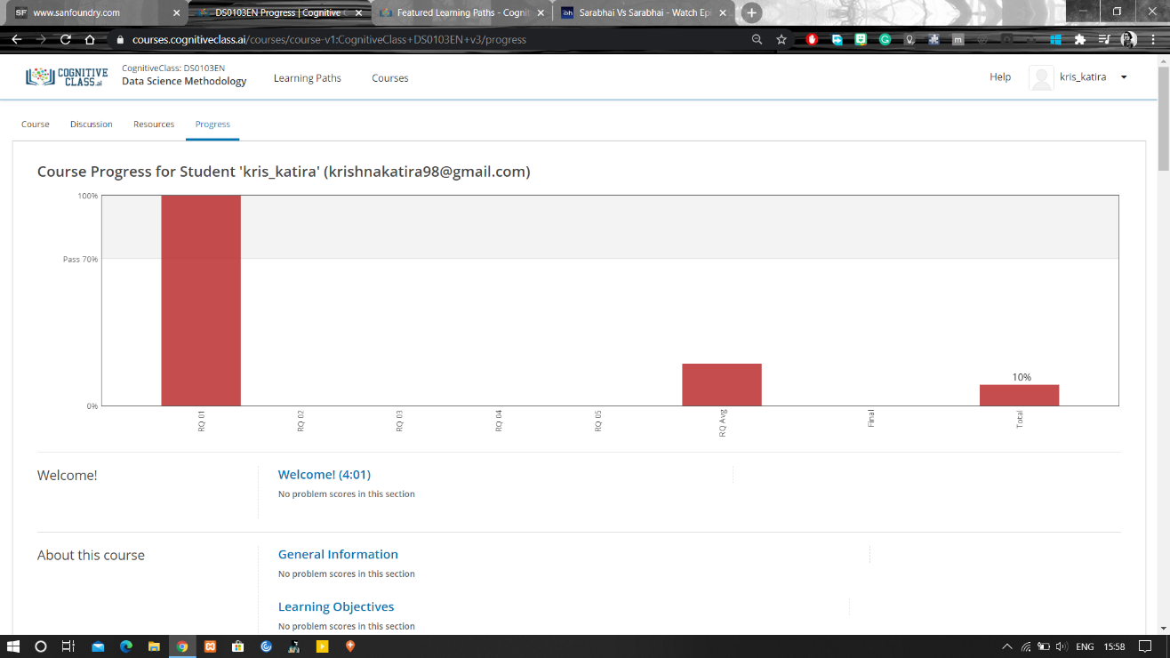

Coding Challenges Details:

**Program:**

class sub:

def f1(self, s1):

return self.f2([], sorted(s1))

def f2(self, curr, s1):

if s1:

return self.f2(curr, s1[1:]) + self.f2(curr + [s1[0]], s1[1:])

return [curr]

a=[]

n=int(input("Enter number of elements of list: "))

for i in range(0,n):

b=int(input("Enter element: "))

a.append(b)

print("Subsets: ")

print(sub().f1(a))